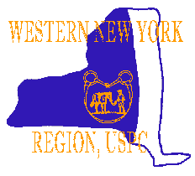

QUIZ 2019
March 30, 2019
Hosted by Lake Effect Pony Club
Alexander Central Schools
3314 Buffalo St.
Alexander, NY 14005
Registration 8:30-9:00 am Mandatory Briefing at 9:15 Competition begins at 10 am
Chaperone forms are available on the Pony Club website. Each team must have at least one volunteer besides the chaperone to help at the rally. As per USPC rules, all members must wear a medical armband at all times. We will be offering a special Jr.D division for Unrated and D1 Pony Clubbers (Jr.D/A) Please indicate on the entry form which members will be on a Jr d/a team or they will be placed on a qualifying team. Only Unrated and D1 Pony Clubber’s 12 and under can enter this division. The Jr.D/A division is not a qualifying division for Championships. Pony Clubbers over the age of 21 must compete as a C3 regardless of their current rating level. Horse masters are welcome to attend. Please highlight any pony clubber that wishes to have the test read to them on the entry form.
Please send your Entry Form, and Chaperone Form, along with payment of $30.00/registrant, $120.00/4 person team - payable to Lake Effect Pony Club
Lunch this year will be available for purchase at the school. Lunch is included in the rally fee for competitors.
Entries must be postmarked by March 1th 2019. Mail to:
Lake Effect Pony Club
4 Meadowlark Dr
Fairport, NY 14450
***Please note – absolutely NO late entries will be accepted!***
Any Questions Please contact: Kaitlin Niven (585) 545-0166 or email: nivenkaitlin@gmail.com

Directions to Quiz Rally
From the East: Take the NYS Thruway to exit 48 Rte. 98 (Batavia). Follow Rte 98 South approx. 10 miles to Alexander, NY turn right onto Buffalo Street the school is on the left. (See map for site location and parking)
From the West: Take the NYS Thruway to exit 48 Rte. 98 (Batavia). Follow Rte 98 South approx. 10 miles to Alexander, NY. Turn right onto Buffalo St. the school is on the left. (See map for site location and parking)
From the Southeast: Take the 390 north to the Avon exit. Take Rte 20 west to Rte 98. take 98 South to Buffalo St. Turn right onto Buffalo St. the school is on the left. (See map for site location and parking)
From the South: Take Rte. 98 North to Alexander, NY. Turn Left on Buffalo St. the school is on the left. (See map for site location and parking)
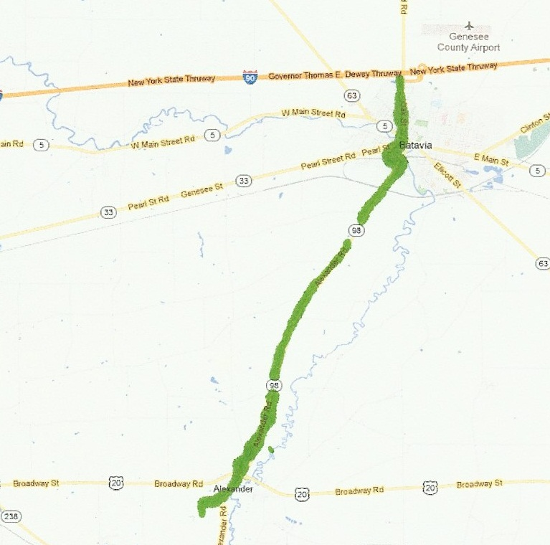

Hotels
The closest lodging for those wishing to spend the night is in Batavia, N.Y. Most of the hotels are on Park Rd. Directly across Rte. 98 from the Thruway Toll.
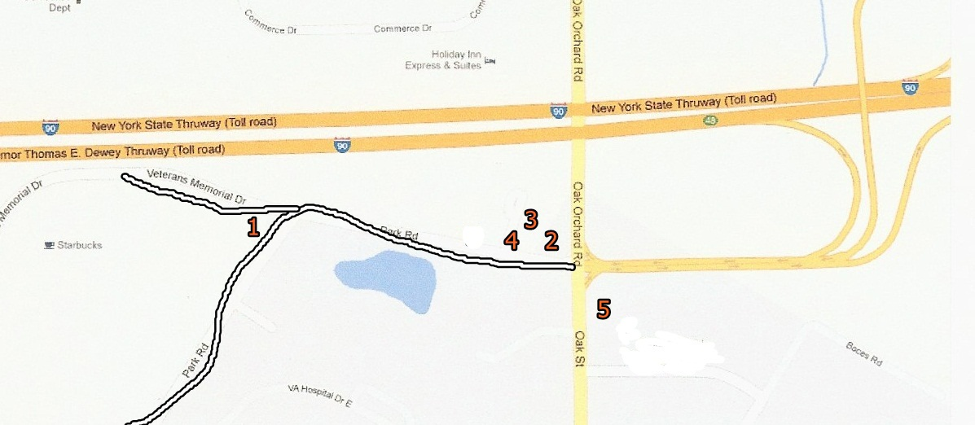
1. Clarion Hotel Palm Island Water Park
8250 Park Rd. Batavia, NY 585-344-2100
2. Quality Inn
8200 Park Rd. Batavia, NY 585-344-7000
3. Travel Lodge
8204 park Rd. Batavia, NY 585-343-1000
4. Best Western Crown Inn
8210 park Rd. Batavia, NY 585-344-8882
5. Days Inn
200 Oak St (Rte 98) Batavia NY 585-343-6000

Parking and Rally Site
Once you turn off Buffalo St. this is the school complex map.
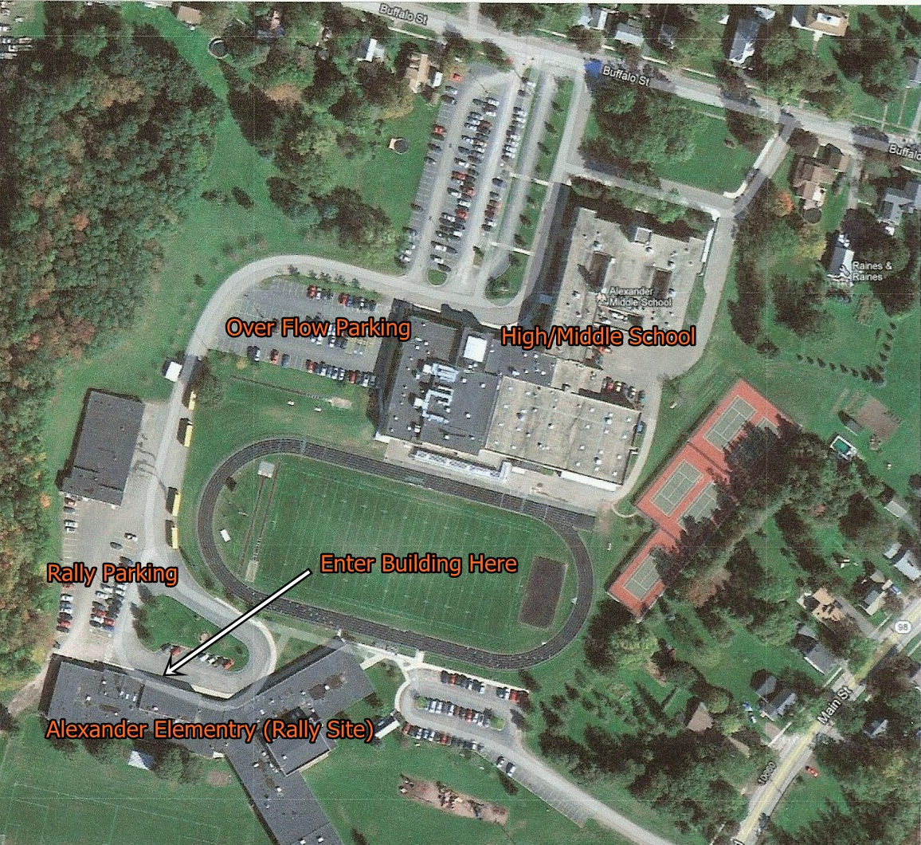
You will be entering the school complex from Buffalo St. (blue dot) drive through the high school parking lot and turn right follow the road passed the bus garage to the rally parking lot.

Lunch Break
Our gathering room will be the school cafeteria, you are welcome to pack a bag lunch or purchase lunch on site and eat in that room. Other options include the Alexander Deli on the corner of Buffalo St. and Rte.98 (walking distance from the rally). Their menu includes Pizza, Wings, Salad, burgers and a store full of munchies and drinks. It also has a small lunch counter where you can sit and eat. Across the street from the Deli is J Dubbs Pizza shop. They have a typical menu (takeout only). There is a Burger King and Subway 5 miles south on 98 in Attica, NY Just take 98 south to prospect St. and turn left. The school is letting us use their facilities please keep it clean. Thank you
